If you opted in to the school directory, you were sent an email from Join Our Class inviting you to the online school directory. You can set up your account by clicking the link in that email.

If you haven’t received an email from Join Our Class, email [laurelschroeder@gmail.com](mailto:laurelschroeder@gmail.com)

Instructions for using Join Our Class:

➮To access the online directory, visit: <https://burnspark.joinourclass.com/member/login>

Log in using your email address and the password that you registered with.

The home screen (below) allows you to edit your profile (top right corner), and to change the directory views by selecting the various tabs (below the black bar). The two tabs that will be most helpful are Classes and Families.

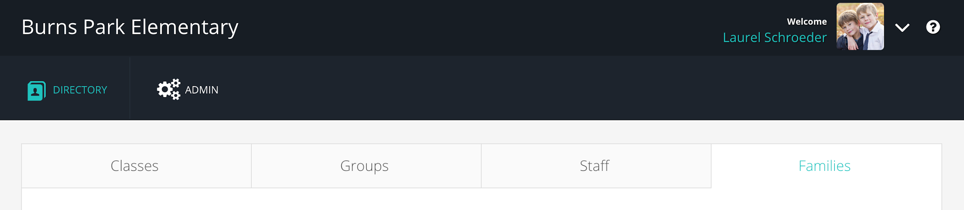

To find a child or parent by name search:

Select the Families tab (far right side), 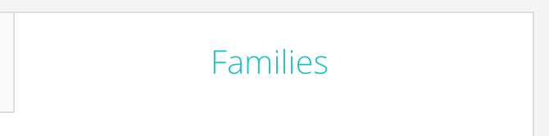

and use the search bar to find the child or parent you’re looking for.

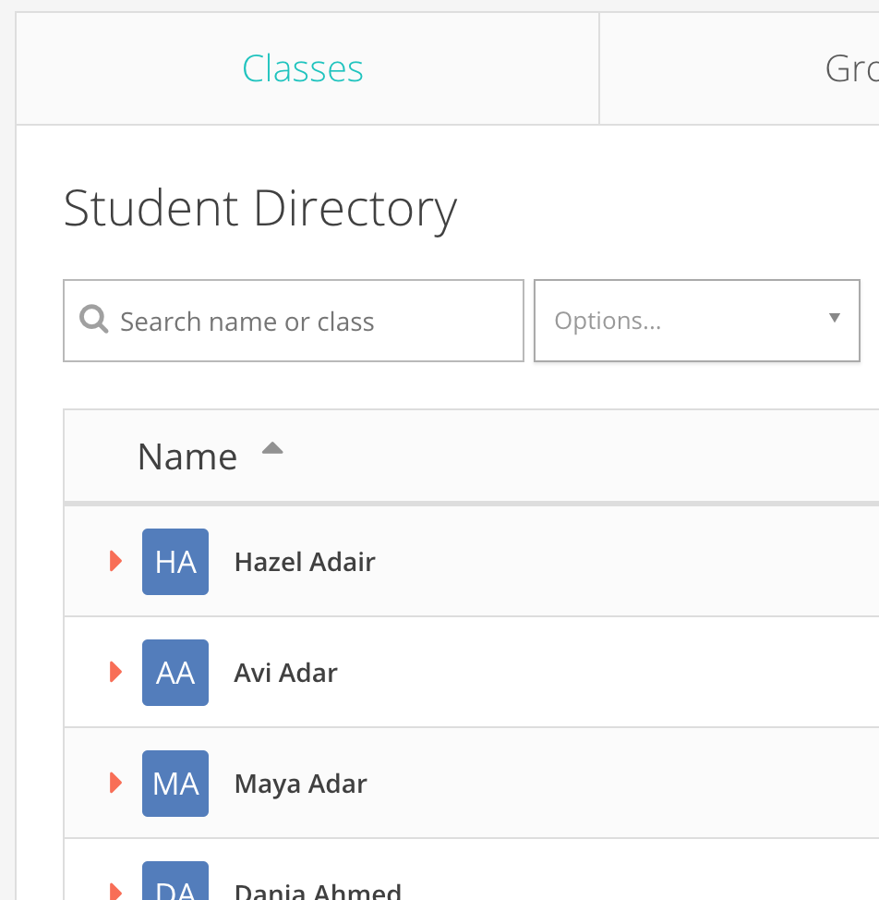

You can sort your results by student/parent view using the buttons on the right hand side of the screen.



You can view a student’s family by selecting the arrow beside their name or by clicking this button

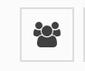

To view the contact information, click on a parent’s name.

To view all students in a particular class:

Select the Classes tab (far left side), 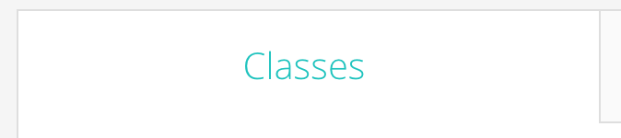

and use the search bar to find the name of the teacher you’re looking for. Click on the teacher’s name to view the students in that class. Click on their parents (listed at bottom along with any siblings) to view their contact information.

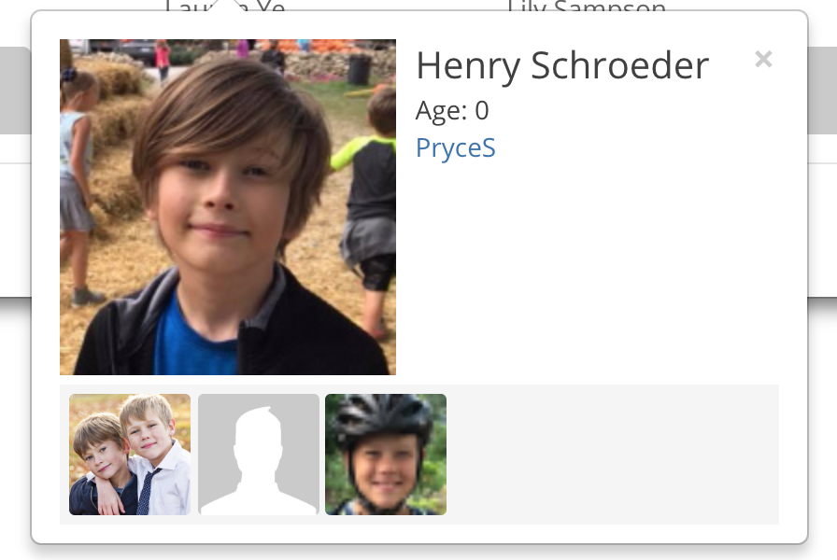⬅

If you have any questions, please contact Laurel Schroeder (619) 952-1103 or [laurelschroeder@gmail.com](mailto:laurelschroeder@gmail.com)